GUIDE TO THE ‘WEAVING EUROPE’ TEMPLATE (16pts-CAPITAL LETTERS)
First Author¹, Second Author² and Third Author³*
¹Affiliation of First Author and Third Author (‘Affiliation’ style)
²Affiliation of Second Author
Received: dd/mm/yyyy  Accepted: dd/mm/yyyy | *Corresponding author: First Name Last name (email@somewhere.com)

ABSTRACT
The abstract must be up to 250 words written in Times New Roman 10.

KEYWORDS: Up to 5 comma-separated keywords or key phrases.

INTRODUCTION
For consistency in producing your document you are advised to use this template and directly insert your text in this document.
It is advised that you keep in mind the following guidelines:
- Keep the order of the document sections as provided in this template: Title, names, affiliations, abstract, keywords, sections, acknowledgements, references.
- Do not leave any spaces at the beginning of each paragraph. The template takes care of paragraph spaces.
- For figures and tables see next paragraph
- Take care not to delete the section breaks before the Introduction and before the References in order to keep the proper page format.
- DO NOT leave extra paragraph spaces, EXCEPT in the following cases:
  - One extra paragraph space is needed before each Figure.
  - One extra paragraph space is needed before and after each Table.

- Figures and tables
Figures should be centred in the column. Figure format is ‘Figure’ whereas table format is ‘Table-Text’. The figure legend should be placed below the figure using the -Figure-Caption style and can be automatically assigned by using the Insert > Caption option (either from the tab-bar or from the menu), or the Insert > Reference > Caption in earlier versions of MS Word. All figures should be referenced in the text (Figure 1). In addition to being inserted in the text, the figures must be sent in good quality. The following file types are acceptable:
- Adobe Illustrator: All formats are acceptable. If using versions earlier than 9 please make sure that all fonts are embedded or included on the disk, or save them as a .pdf file.
- Adobe Photoshop: All formats are acceptable.
- .pdf files: Use high resolution only. Embed all fonts and do not compress images when distilling.
- TIFF, EPS: These are the preferred formats for scanned images. Scan photographic prints at 600 dpi, slides at 1200 dpi. Scan black and white line artwork at 600 dpi; Scan mixed line and tone illustrations at 600 dpi.
- (JPEGS are acceptable if saved to maximum quality.) Submit the image in the size it is intended to appear.

Tables, just like figures should be captioned and styled with Table-Caption, as shown in Table 1. Table captions are placed above the table and centred. Tables must also be referenced in the text (Table 1). Tables should have one paragraph space before and one after.

- Excel or Word: Use for tables Times New Roman in point size 9
- Excel: Charts and graphs should be designed to appear in black and white. Use patterns to distinguish bars on graphs, etc. rather than colour or tone, which loses clarity when printed in black and white.

Table 1. This is an automated table caption.
Head 1 | Head 2 | Head 3 | Head 4 | Sum
1 | 1 | 1 | 1 | 4
2 | 1 | 2 | 2 | 7
3 | 2 | 2 | 2 | 9
4 | 2 | 3 | 2 | 11
5 | 3 | 3 | 3 | 14

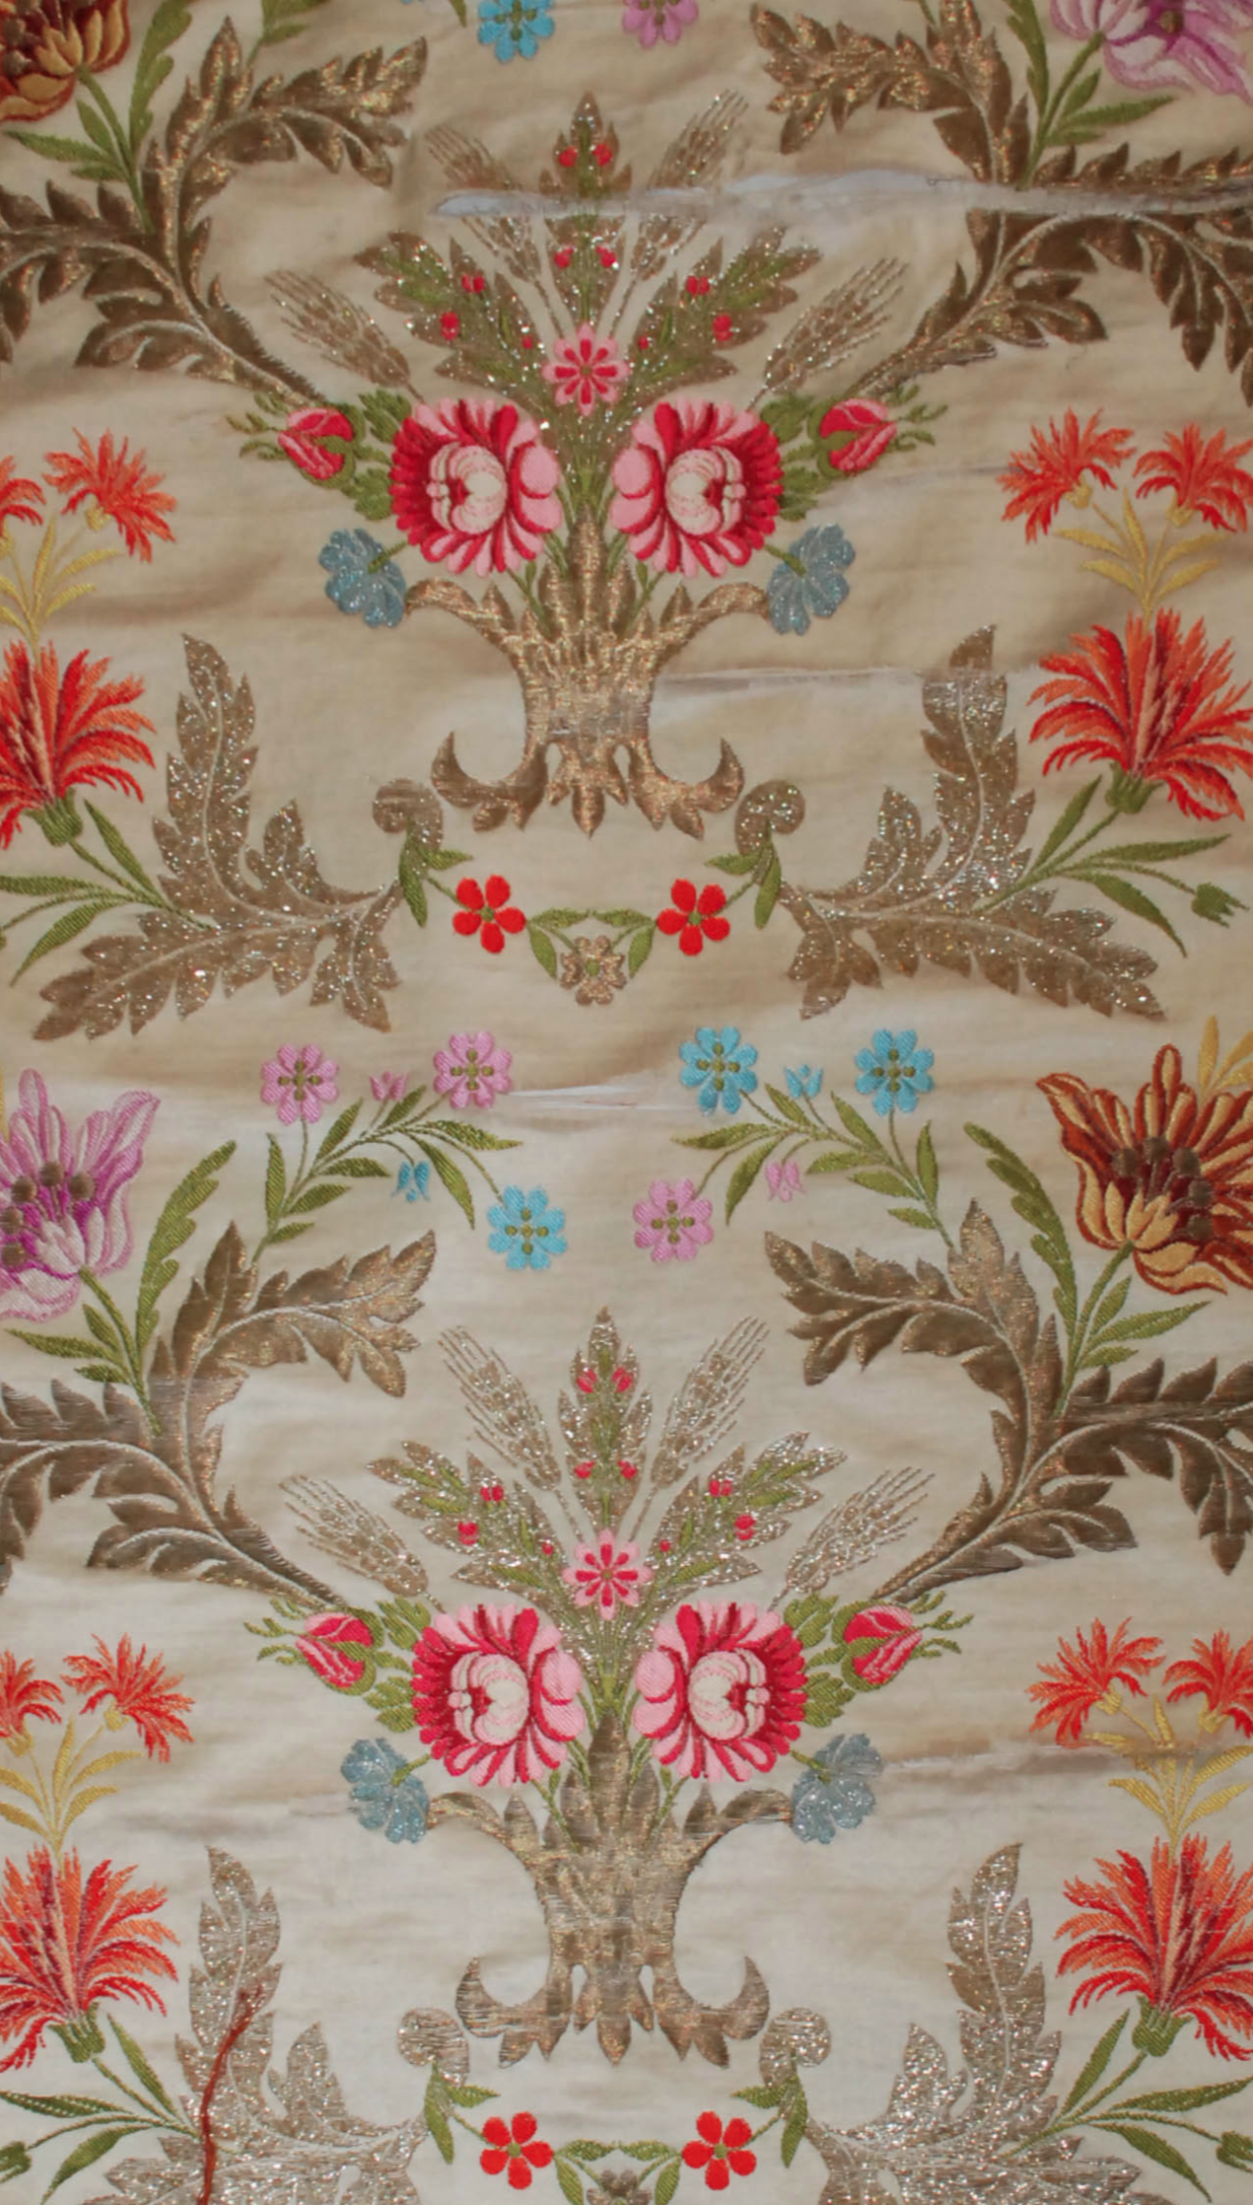
Figure 1. This is an automated figure label.

Sub-subsection level 3
Use Heading-3 style for sub-subsections: Times New Roman, 11, bold.

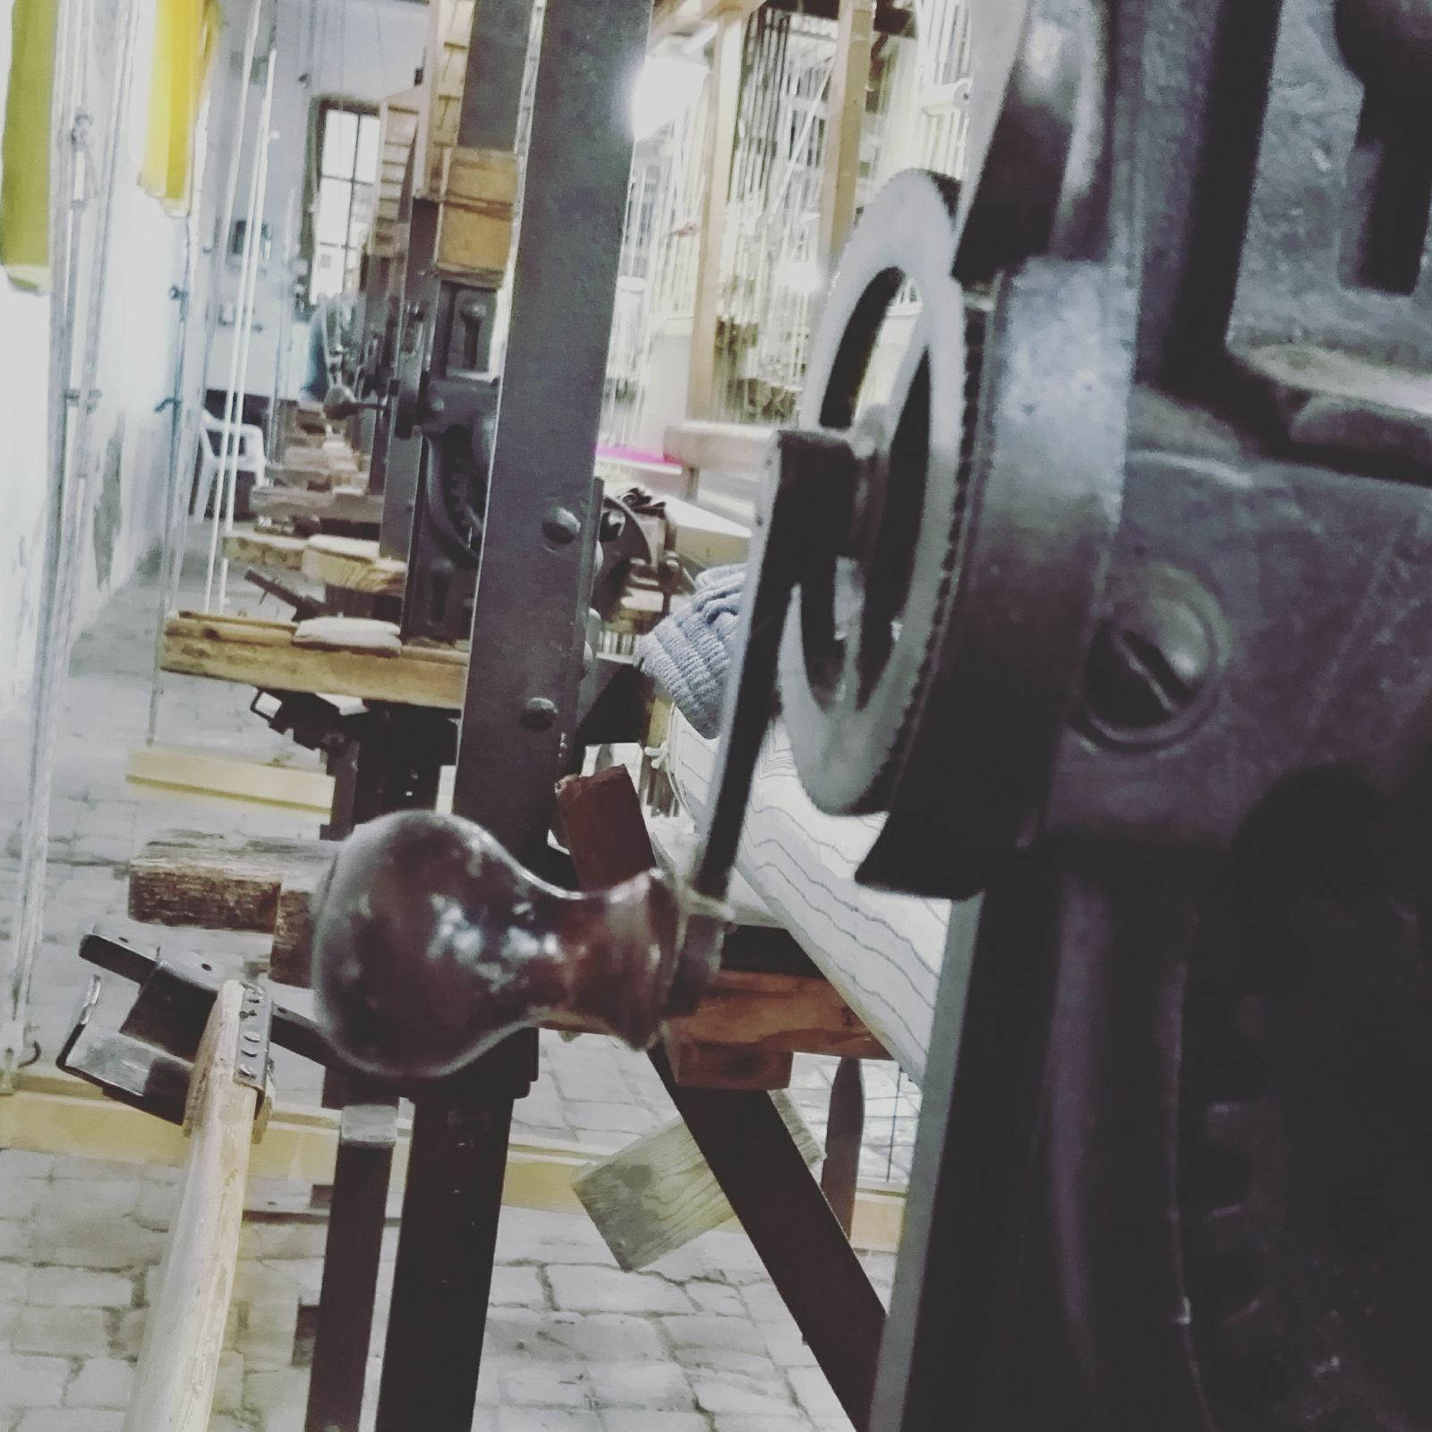
Figure 2. This is the figure legend of a single column figure.

      - Sub-Sub-Subsection Level 4
Use -Heading-4 style for sub-sub-subsections: Times New Roman, 11, underline.

- ACKNOWLEDGEMENTS
This project has been funded…
- References
References should be again in single column format and provided in alphabetical ordering starting with the first author’s surname and all names capitalized. Use the Reference style for references, which corresponds to Times New Roman 10pts. To use references in the paper use the following example (Varela et al., 2007; Chiari, 2012).

REFERENCES
BOOK
REENTS-BUDET, Dorie, 1994. Painting the Maya Universe: Royal Ceramics of the Classic Period, Duke University Press, Durham y Londres.

BOOK WITH AUTHOR/EDITOR
VIDAL LORENZO, Cristina y Gaspar MUÑOZ COSME (Eds.), 2009: Los grafitos mayas. Cuadernos de arquitectura y arqueología maya 2. Editorial UPV, Valencia.

JOURNAL
HOUSTON, Stephen D., 2000. Into de Minds of Ancients: Advances in Maya Glyph Studies. Journal of World Prehistory, 14 (2): 121-202.

CHAPTER BOOK
MASON, Marilyn A., 2002. Introduction. En Ancient Maya Polictical Economies, M. A. Masson y D. A. Freidel (Eds.), pp.1-30. Altamira Press, Nueva York.

PROCEDINGS
HOUSTON, Stpehen D. y Héctor L. ESCOBEDO, 1997. Descifrando la política maya: perspectivas arqueológicas y epigráficas sobre el concepto de los estados segmentarios. En X Simposio de Investigaciones Arqueológicas en Guatemala, J.P. Laporte y H.L. Escobedo (Eds.), pp. 463-481, Ministerio de Cultura y Deportes, Guatemala.

THESIS, REPORTS, AND OTHER MANUSCRIPTS NOT PUBLISHED
FERNÁNDEZ MARQUÍNEZ, Yolanda, 1992. Excavaciones en el Grupo May. Tesis doctoral inédita (M. Rivera Dir.). Universidad Complutense de Madrid, Madrid.

